
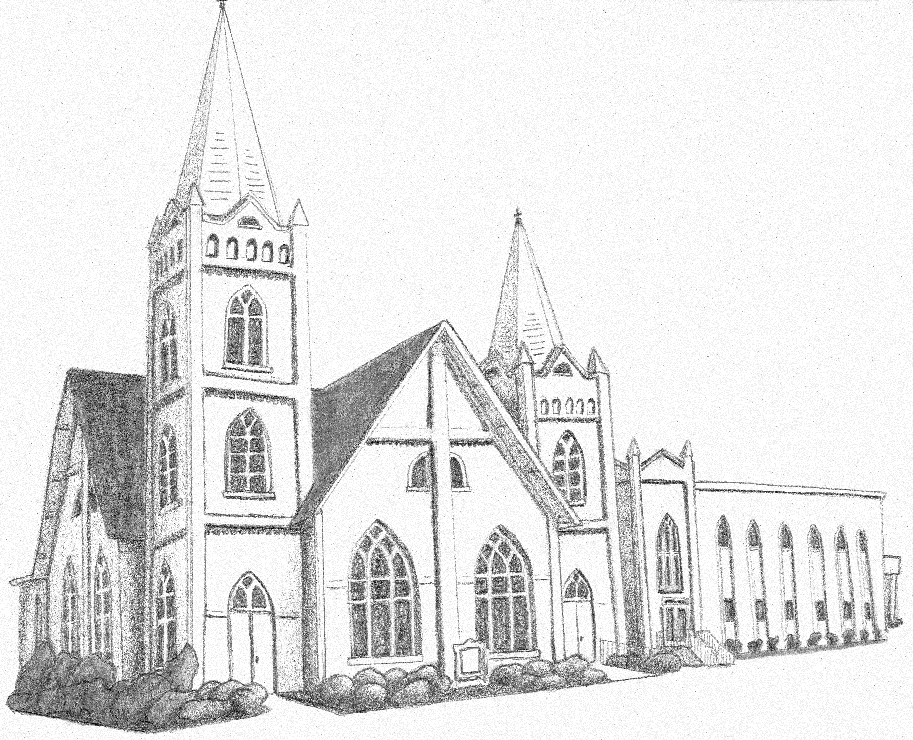
Martin First United Methodist Church
INTERCESSORY PRAYER CONCERNS: We ask for your prayers and continued prayers for these we know of. Several more have asked us to keep their situations private. If God places someone’s name on your heart, please consider sending a note or giving them a call.

Ongoing Concerns: All impacted by Hurricane Helene & Milton. Charlotte May. Andy Lewter. Walton West. Jamie Babb. Penny Knipper. Susan Kilgas. Herman & Vicki Smith. Wally Crider. Linda Davis. Glenda Nanney. Doris Jackson. Jake, Caroline & Josie Claire Reynolds. Carter Unger. Sarah Byars. Greg Moore. Teddy, Tanner & Stevie Owensby. Richard Guthrie. Bryant, Amy, Ella, Jack & Julia Fisher. Steve Lemond. Stephanie Mueller. Chris Smith. Carol & Dave Politte. Mary Beard. David & Carol Reed. Don Clements. Donna Webb. Wally Crider. Leslie Morris. Magen, Braden and Jase Cooper. People in Israel and Palestine. Steve Mohler. Patsy Coates. Marion Pitts. Rosemary Capers. Diane Broughton. Donna Flynt. Paula Moore. Bob & Kay Carroll. Will King. Janice Noble. Kristen Havener’s son, Kaden. Jim & Gina Johnson. Gail Beard Yates. Frances Brewer. District Superintendents Stephen Handy & Nancy Varden. We Care Ministries. UTM Wesley – Mollie June Miller & Megan Lewter. Dresden UMC. Exceptional Worship. Prayers for Friends and Relatives: Bill Porter’s sister-in-law, Debra Porter. Amanda Jackson's colleague, Jolene. Allen Beard's father-in-law, David. Mona Abu El-assal and family. Doug Owens’s mother, Mary. Katharina Speelman. Robert Lovell’s mother, Joyce Lovell. Mary Beard’s daughter-in-law Patrea Beard. Michael Johnson’s father, Jerry. Karen Hester. Dee Cannon’s friends, Amy Garner & Jeff Wright. Jeff Stockton’s dad, Sam Stockton. Jen Galey’s mother, Janet Flynn. Chris Bowman’s father. Dave Politte’s brother, Alan. Janice Noble’s sister, Peggy. Roger Johnson’s mother. Crawford & Nancy Gallimore. Renee LaFleur and Ricky Garlitz. Kristy Shumake’s mother, Brenda Dublin.
Van Ayer: Bob Smith, Patsy Coates, Don Clements, Sarah Byars
Arbors: Linda Hall.
Weakley County Nursing: Alan Moody, Jean Vincent
Greenbrier Residential: Bev Eaton.
At Home: Mary Vowell, Janiece Peeler, Marilucile Counce, Jane & Jim Rea, Sue Wright. Away: Bertha Lou Smith, Betty Henderson.

Office Hours: Monday-Thursday 8-12 & 1-5

Closed Friday

Pastor, Amanda Crice
Monday 9:00 - 3:30
Tuesday study out of the office;
Wednesday & Thursday 9:00-4:00
Friday Sabbath

Director of Music & Worship Arts,
Chrissy Hamilton
Monday & Wednesday 8:00-2:00
Tuesday & Thursday: 8:00-2:15 KDO

Pastor of Students & Nurture, Bryant Fisher
Mon. 8:30-4:00; Tues. 9:00-4:00
Wed. 7:30-2:30, Thurs. out of office

Director of Children, Jennifer Vincent
Monday 8:00-5:00 (ROOTS 3:00-5:00)
Tuesday & Wednesday 8:00-11:00

Financial Secretary, Kathy Smith,
Wednesday 8:30-4:00

Administrative Assistant, Judy Mehan
Mon. Tues. Wed. Thurs. 8-12 & 1-5

Building & Grounds Supervisor, Ken Hogan
Monday -Friday 7:30-4:00

Chancel Choir Director, Robert Mancusi

Minister of Visitation, Bro. Randy Cooper

Wesley of UTM Director: Mollie June Miller
Mon. 9-12 & 3-7; Wed. 1-7; Thurs. 11-3
Wesley of UTM Assist. Director: Megan Lewter Mon.-Thurs. 9:00-12:00

2024 Council Chair: Claire Wade
Lay Leader: Andy Lewter
Worship Chair: Gayle Emro-Cooper
Nurture Chair: Caroline Ideus
Serve Chair: Mary Margaret Chester

Worship, Nurture and Serve in Love
First Sunday of Advent
December 1, 2024

ENTRANCE

WELCOME & ANNOUNCEMENTS Pastor Bryant
Fisher
PRELUDE

CALL TO WORSHIP Pastor Bryant

OPENING PRAYER Bob Peckham

OPENING HYMN O Come, O Come, Emmanuel 211

PROCLAMATION & RESPONSE

PRAYER OF ILLUMINATION Ancient Words

OLD TESTAMENT Isaiah 43:1-7

ANTHEM O Come to Us, Emmanuel Choir

CHILDREN SERMON

ADVENT WREATH The Haley Family

GOSPEL READING Luke 1:26-38

SERMON Pastor Amanda
Christ-centered people who worship God, nurture disciples, and serve our neighbors with love

PRAYERS OF THE PEOPLE Pastor Amanda

OFFERING
Offering Steward: John Haley

DOXOLOGY

THANKSGIVING & COMMUNION

COMMUNION

LORD’S PRAYER

SENDING FORTH

HYMN It Is Well With My Soul 377

BENEDICTION

Thank You
Many thanks to my church family for the cards, visits, prayers and meals. My bazaar girls really supported me during this time. The Roots Kids as always brightened my day with their card. I continue to heal and get stronger every day.
Susan Kilgas

Dear Friends,
Your continued generosity to the Backpack Program is truly appreciated. We are serving about 400 school children each weekend. Some additional holiday food has also been purchased. You all are a blessing to the children and we are grateful.
Sincerely, The Weakley County Backpack Program
HAPPENINGS

The Bell Choir practices today at 3:00 in the choir room. Hands for Him meets at 4:00.
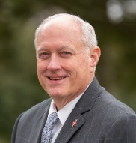
You are invited to meet Bishop David Graves at a gathering hosted by Fulton FUMC this Tuesday from 5-7pm.
Calendar
Sunday, December 1
3:00 Bell Choir
4:00 Hands for Him
5:00 Youth/Student Ministry Area
Monday, December 2
3:00 ROOTS
Tuesday, December 3
5-7 Gathering w/Bishop Graves/Fulton FUMC
5:30 Disciple 2 with Jenise Butler
Wednesday, December 4
6:45 United Methodist Men/Fellowship Hall
9:30 Wee-Ones Wednesday
5:15 Wesley at UTM Dinner, 6:00 Worship
5:30 Disciple 1 & 3
6:00 Secret Santa Shopping/Fellowship Hall
7:00 Choir

Save the date!
- Live Nativity – December 15 5:00-7:00 pm
- Christmas Eve Service 5:00

Join us for Secret Santa shopping for Carl Perkins kids this Wednesday at 6:00 in the fellowship hall. Wrapping paper and trims donation appreciated.

A trip to the Jackson Symphony is planned for Sat. Dec. 7th 11 am performance. Adults $15, children $10.
Tomorrow is the deadline to signup and to pay.

The last Worship & dinner with Wesley of UTM students is this Wednesday night at 5:15. Fellowship resumes Wednesday, January 15.

You are invited to the United Women in Faith Christmas Brunch at 10:00 Saturday, December 14 in the fellowship hall. Mollie June Miller, Wesley of UTM Director, will be the speaker.

For December’s Communion offering, choose your favorite ministry from Grace Place Prison Ministry, Project 20/20, Reelfoot Rural Ministry, Dayshore, Wesley Sr/Golden Cross, UMCOR, Lakeshore Camp & Retreat Center, Kids Day Out, We Care Ministry, Weakley County Backpack or Hunters for the Hungry.
United Women in Faith
Mission Focus—USA
Asheville, North Carolina—Brooks-Howelll Home
Mission Focus—International
Nairobi, Kenya—Wema Health Foundation

Sunday, Dec. 15 is the deadline if you'd like to honor or memorialize a loved one for Christmas by placing a poinsettia plant in the sanctuary. A plant is $20. Include name and address for acknowledgements.

Signup sheets for the Live Nativity on Sunday December 15 from 5:00-7:00 are in the narthex. We need cast, set-up and cleanup crews, and food for the cast as well as set up and take down of the stable.
Memorials & Honorariums
Honoring and remembering those we love

Budget in honor of Amanda & Justin Crice, Candy Goad, Pat Page, Madilyn Pritchett, Cathy & Nick Dunagan
Budget in memory of Casey Dunagan, Dale & Nancy Overton, Dee Pritchett, Jimmy Jackson

